Fundamental Issues in Non-Equilibrium Dynamics

Table of Contents

Section Page
1. Overview
1.1 Models of Non-equilibrium Systems 3
1.2 Thematic Organization 4
1.3 Choice of Experimental Systems 5
1.4 Research Team 6
2. Technical Approach
2.1. Theme 1: Universal features in quench dynamics 8
2.2. Theme 2: Holographic approach to quantum 12
critical dynamics
2.3. Theme 3: Entropy management and adiabaticity 16
2.4. Theme 4: Quantum origin of thermalization 18
2.5. Summary 21
3. Project Schedule, Milestones and Deliverables 22
4. Management Plan 23
5. Facilities, Resources and Equipment 26
6. References 28

1. Overview
We have composed a team of four experimentalists and five theorists to work collaboratively on a set of fundamental and highly challenging problems in non-equilibrium quantum systems. Our emphasis is on the discovery of general governing principles and tests of fundamental hypotheses in many-body quantum dynamics. We use atomic gases as highly controllable model systems for gaining these insights.

The non-equilibrium behavior of quantum systems has immense technological importance, as well as being an exciting scientific frontier. The significance of this research direction extends beyond the boundaries of any one discipline. Experimental progress is rapidly being made in areas ranging from chemistry and biology [1, 2] to physics and material science [3-6]. Recent theoretical progress includes surprising connections between the dynamics of black holes and the equilibration of model solid state systems [7]. These developments reveal a richness that transcends our intuitive understanding, and provides a perspective for new discoveries, inventions, and fundamental paradigms in which to frame our understanding of non-equilibrium quantum phenomena.

1.1. Models of nonequilibrium systems
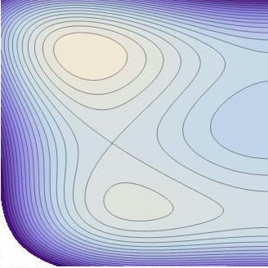
While there is currently no universal paradigm for nonequilibrium dynamics, one starting point for is to consider the “entropy contour landscape” (see Figure 1), where the entropy of the nonequilibrium system is presented as a function of some internal coordinates. For example in a classical gas the axes might be moments of the phase space distribution function (density, pressure, temperature…).
Figure 1 Entropy landscape in a parameter space: Equilibrium (A with S=S_{max}), near equilibrium (D), saddle B, and metastable state (C). Red arrows show the evolution predicted by thermodynamics and quantum mechanics. Lighter colors denote higher entropy. Lines are isoentropy contours
A
B
C
D
QM
Thermo
S=const.

For a system sufficiently close to the equilibrium state (A in Figure 1), its evolution is described by linear response theory, and one can define the standard set of transport coefficients (conductivity, viscosity…) which measure how quickly the system approaches equilibrium. The simplest hypothesis for the far-from-equilibrium system is steepest entropy ascent (red arrow D toward A) [8]. Such a model obeys the Onsager relation [9,10]. One intriging feature of this model is that it predicts that some systems will never equilibrate: for example, these dynamics can drive one to a local maximum (C) in entropy space which is distinct from the equilibrium state (A).

Steepest ascents has several weaknesses. Most dramatically, in an isolated system, the von Neuman entropy 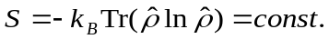 remains constant throughout unitary evolution, (red arrow marked “QM”). This prediction is exactly orthorgonal to that made by the steepest entropy ascent hypothesis. This contradiction is largely related to the lack of an unambiguous microscopic definition of entropy in an interacting non-equilibrium system.

One remedy that has been widely discussed in recent years is the eigenstate thermalization hypothesis [11], which suggests that for a “sufficiently complex” system, thermodynamic observables of any single many-body eigenstate distribute indistinguishably from a Gibbs’ ensemble. This hypothesis appears to correctly describe some numerical models, but has not yet been confirmed experimentally.

Regardless, in its simplest form, the eigenstate thermalization hypothesis does not tell the entire story of how non-equilibrium systems evolve, rather it just concerns the end-point. Unanswered questions include: Are there universal features of the dynamics of a system pushed far from equilibrium? How can one understand the phenomonology of transport and equilibration for systems where the microscopic degrees of freedom are strongly interacting, and quantum mechanically entangled? How can we control the equilibration process in order to generate minimal entropy during our manipulation of quantum systems? Similarly, how can we produce more efficient methods of cooling?

Because of the fundamental importance of these issues, which span a vast array of physical systems, we have focussed our research program on this terra incognito where new paradigms are just being developed. Our focus is on universal, general principles that impact our understanding of nonequilibrium phenomena.

1.2. Thematic Organization
Table 1 shows the themes we use to organize our research questions, and the experimental systems we will use to explore them.

Table 1. Research themes and the team organization

Theme  System | 1. Quench  dynamics | 2. Quantum critical dynamics | 3. Entropy control & adiabaticity | 4. Quantum origin of thermalization
1D  Fermi | ⁷Li lattice (Rice) |  |  | ⁶Li lattice (Rice)
1D  Bose | ⁷Li spinor (Cornell) |  |  | ⁸⁷Rb lattice (MIT)  ⁷Li spinor(Cornell)
2D  Fermi |  |  | ⁶Li gas (Chicago)
2D  Bose | ⁷Li spinor (Cornell)  ¹³³Cs gas (Chicago) | ¹³³Cs lattice  (Chicago)
3D  Fermi |  | ⁶Li gas (Rice) |  | ⁶Li lattice (Rice)
3D  Bose | ⁸⁷Rb lattice (MIT) |  | ⁸⁷Rb lattice (MIT)  ⁷Li lattice (MIT)  ⁷Li spinor(Cornell)
Theory  support | Ho, Mueller, Sachdev, Son,  Giamarchi | Sachdev, Son | Ho, Mueller, Giamarchi | Ho, Mueller, Sachdev, Giamarchi
Theme One - Quench dynamics: A powerful technique for generating far from equilibrium states is to “quench” a system, changing its properties faster than the microscopic response times. Such quenches are ubiquitous, even occurring in the early universe, and can drive transport. We will explore the universal aspects of quench dynamics, the subsequent restoration of equilibrium, and the quantum nature of transport in 1D systems. There exist extensive theoretical models of universality in quenches (for example the Kibble-Zurek mechanism) and part of our task is confirming these features, and extending them into new regimes.

Theme Two – Critical dynamics, black holes, and the quark-gluon plasma : In strongly correlated systems, or those near quantum phase transitions, there are no simple descriptions in terms of weakly interacting particles. Hence even the near-equilibrium dynamics are opaque. Over the past decades, techniques have emerged which map classes of critical models onto problems in classical or quantum gravity, allowing one to both quantitatively calculate their properties, but also identify universal features. Working with systems which are amenable to this mapping, we will explore the validity of this approach, and compare it with other promising techniques.

Theme Three – Entropy control and adiabaticity: The third theme addresses issues of controlling the temporal and spatial distribution of entropy in a quantum system. How does one bring a system from one phase to another without generating a great deal of entropy? How can one use spatial anisotropies to sequester entropy, allowing the production of lower temperatures?

Theme Four – Quantum origin of thermalization and entropy production: The fourth theme focuses on issues related to how isolated quantum systems equilibrate. It involves a number of thrusts, including: The emergence of collective excitations which drive equilibration, and the role of conservation laws in integral systems that prevent equilibration. There are close connections with this theme and theme one, as quench dynamics can amplify quantum effects.

1.3. Choice of Experimental Systems
In order to uncover fundamental principles, it is important to work with systems that allow creation of both non-equilibrium and equilibrium states with high precision over a wide range of parameters. These experimental thrusts must be supplemented with systematic and rigorous theoretical studies. From this viewpoint, quantum gases are ideal. Some relevant features include:
A. Interaction and external potentials that can be controlled with high precision. This enables the creation of a great variety of non-equilibrium states, where precise investigations of important equilibrium properties (such as quantum criticality, strong correlations, symmetry and topological constraints) affect non-equilibrium processes.
B. Because quantum gases are extremely clean systems, interpretation of experimental results will not be plagued by sample quality or uncontrolled disorder. On the other hand, disorder may be introduced in a controlled manner, which is usually difficult or impossible to do in solid state systems.
C. The microscopic equations of motion of quantum gases are known, thus eliminating the major problem of finding the proper model of complex phenomena. Despite this, these systems display the full richness of emergent phenomena seen in other physical systems.

Our experimental groups possess capability to access a complete set of quantum gases of various types: bosons and fermions, in 0D, 1D, 2D and 3D, scalar/pseudo-spin/spinor systems. The experimental systems are on four different atomic species fermionic Li-6, bosonic Li-7, bosonic Rb-87, and bosonic Cs-133.

1.4. Research Team
Our experimental and theoretical teams have rich experience in cold atom research and, in particular, have all made significant contribution to non-equilibrium dynamics of quantum gases.
Cheng Chin (Principle Investigator)
Associate Professor, James Franck institute and Departments of Physics, University of Chicago, Chicago, IL
Tel: (773) 702-7192, Fax: (773) 834-5250, Email: cchin@uchicago.edu
Cheng Chin will lead an experiment team at the University of Chicago to investigate non-equilibrium dynamics of 2D Bose and Fermi gases. Chin has studied quench transport [12] and quench dynamics, and reported a coherent Sakharov oscillations in quenched 2D superfluids [13]. His work on the quantum criticality in 2D lattice bosons [14] lays the foundation to study quantum critical dynamics and to test gauge-gravity duality. Chin provides our team a solid underpinning for the proposed research programs to address various fundamental issues in quantum quench dynamics and quantum critical transport.

Thierry Giamarchi (unfunded investigator)
Professor, DPMC-MaNEP, University of Geneva, Switzerland
Tel: +41 22 379 63 63, Email: Thierry.Giamarchi@unige.ch
Thierry Giamarchi is one of the leading theoreticians in the field of strong correlations in low dimensional systems [15,16] with applications to both condensed matter and AMO systems.
On the equilibrium side he has worked on 1D Luttinger liquids and on the dimensional crossover to higher dimensions. He has also made a number of key studies concerning transport, as well as thermalization and dissipations in out of equilibrium situations in such low dimensional systems [17]. He will bring this expertise to the team and make contact with the corresponding problems in condensed matter such as in the quasi-one dimensional organic superconductors and quantum magnetic insulating systems.

Tin-Lun (Jason) Ho (co-investigator)
Professor of Mathematical and Physical Sciences, Physics Department, Ohio State University, Columbus, OH
Tel: (614) 292-2046, Fax: (614) 292-7557, Email: Ho@mps.ohio-state.edu
Jason Ho is well known in his work at the interface of AMO and condensed matter. He is the first to study mixtures of Bose-Einstein condensates and pioneer the theoretical studies on spinor Bose condensates, a term invented by him. Ho has done extensive work on both the thermodynamics and dynamics of cold gases, including 1D, quantum critical, and spinor gases. He brings a broad condensed matter background, and intends to connect the phenomena in these experiments to those in 2D electron gases, semiconductor wires, and spin chains.

Randall G. Hulet (co-investigator)
Professor, Physics and Astronomy Department, Rice University, Houston, TX
Tel: (713) 348-6087, Fax: (713) 348-5492, Email: randy@ rice.edu
Randy Hulet discovered Bose-Einstein condensation in ⁷Li. His recent work mapping out the T=0 phase diagram of 1D attractive Fermi gas through its density profile in a trap demonstrates clearly the power of quantum simulation. He has a long history in the study of quantum dynamics, including the creation of bright soliton chains [18], dissipative transport of a Bose-Einstein condensate [19] and the thermalization and identification of new quantum phases in a 1D Fermi gas [20]. He is currently developing the method of evaporative cooling in optical lattices, a technique that is essential for all experiments to reach strongly correlated states in lattices.

Wolfgang Ketterle (co-investigator)
Professor, Department of Physics, MIT, Cambridge, MA
Tel: (617) 253-6815, Fax: (617) 253-4876, Email: ketterle@mit.edu
Wolfgang Ketterle has developed several of the systems and techniques on which this MURI program is based, including Feshbach resonances to control atomic interactions and spinor condensates [21]. His group did the first quench experiments with Bose-Einstein condensates when studying the dynamics of condensate formation [22] and the amplification of phonons for condensates with negative scattering length [23] .More recently he has looked for ferromagnetic phases after quenching repulsive Fermi gases to strong interactions [24]. Recent work includes a new cooling method, spin gradient demagnetization implemented by sweeping magnetic field gradients [25]. A similar method can be used to study the limits of adiabaticity and to prepare novel quantum states far away from equilibrium.

Erich Mueller (co-investigator)
Associate Professor, Laboratory of Atomic and Solid State Physics, Department of Physics, Cornell University, Ithaca, NY
Tel: (607) 255-1568, Fax: (607) 255-6428, Email: em256@cornell.edu
Erich Mueller has made contributions to our understanding of kinetics in cold gases, including investigations of quenches in lattice Bose systems [26,27]. He is also an expert on strongly interacting Fermi gases [28], 1D systems [25,30] and spinor gases [31, 32]– all physical systems which are central to our studies. His studies have led to advances in imaging, and other techniques for probing ultracold atoms.

Subir Sachdev (co-investigator)
Professor, Department of Physics, Harvard University, Cambridge MA
Tel: (617) 495-3923. Fax: (617) 496-2545, Email: sachdev@physics.harvard.edu
Subir Sachdev is an expert on strongly correlated and quantum critical systems. He has developed the theories of numerous quantum phase transitions, and applied them to experimental systems in condensed matter and atomic physics. He is one of the leaders in applying string theory and holographic methods to strong coupling problems in the dynamics of quantum many body systems.

Dam Thanh Son (co-investigator)
University Professor, Enrico Fermi institute, James Franck institute and Departments of Physics, University of Chicago, Chicago, IL
Tel: (773) 834-9032, Fax: (773) 834-2222, Email: dtson@uchicago.edu
Dam Thanh Son will apply field-theoretic and holographic approaches to unitary fermions and other systems. He is an expert on the applications of gauge/gravity duality to strongly interacting systems. He also worked in the physics of the quark gluon plasma, cold quark matter, and unitary fermions.

Mukund Vengalattore (co-investigator)
Assistant Professor, Laboratory of Atomic and Solid State Physics, Department of Physics, Cornell University, Ithaca, NY
Tel: (607) 255-8178, Email: mukundv@ccmr.cornell.edu
Mukund Vengalattore has rich experience on the dynamics of spinor BECs [26, 29], and has performed a number of studies on thermalization and pre-thermalization. His recent publications include a very highly cited article, “Colloquium: Nonequilibrium dynamics of closed interacting quantum systems”, in Reviews of Modern Physics [33]. His expertise in quantum-limited nondestructive imaging techniques for spinor gases and the creation of large, spatially extended ensembles of ultracold spinor gases are crucial for the proposed studies on quantum quench dynamics and thermalization.

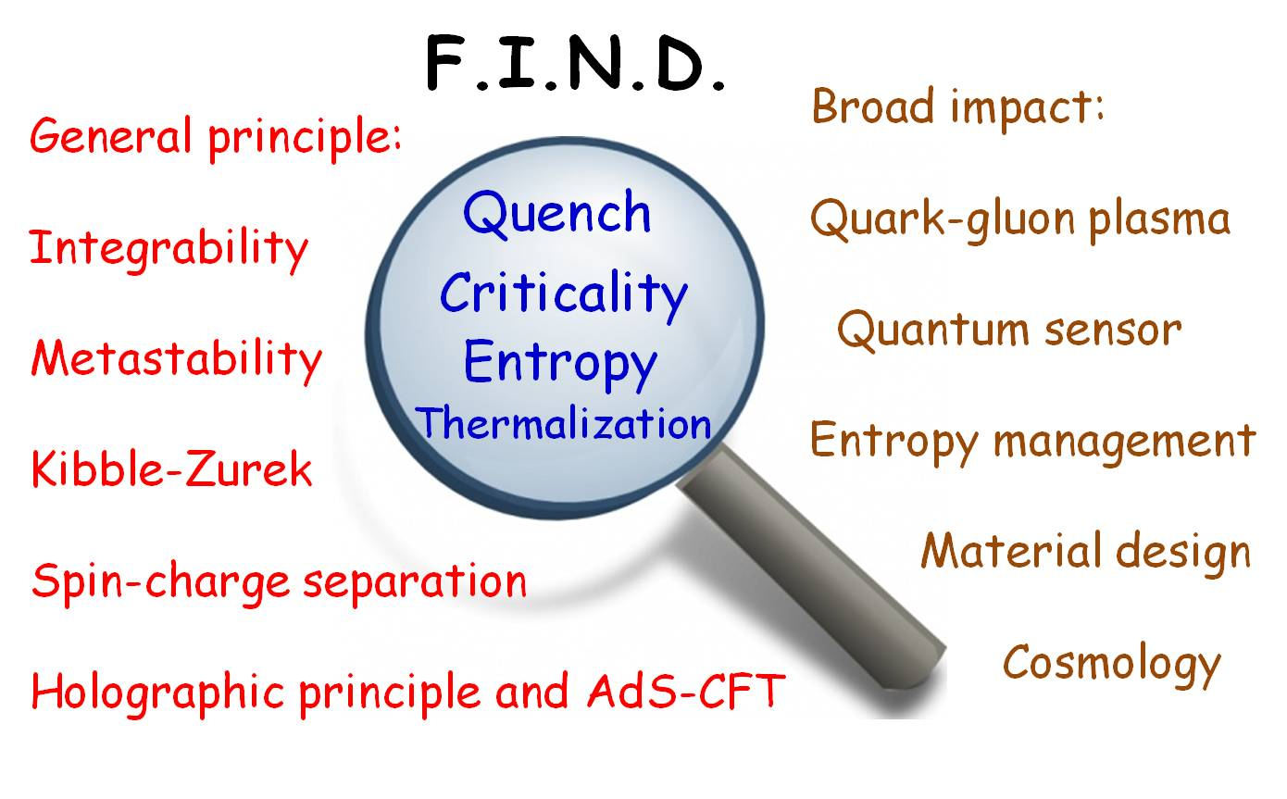
Figure 1: Our team “Fundamental Issues of Non-equilibrium Dynamics” embraces four themes. Our research emphasizes both the universal principles in the far-from equilibrium dynamics, and their potential impact in other branches of physics, material science and quantum control.

2. Technical Approach
2.1. Theme 1: Universal features in quench dynamics
Major questions: How do post-quench dynamics reflect properties of the initial equilibrium state? How does order develop following a quench? How do correlations reestablish themselves following a quench? How does the rate of quenching impact the subsequent behavior?

(A) Investigating Acoustic Peaks with Noise Correlations
As was demonstrated in the Chicago group, one can image how spatial structure evolves with time in a 2D Bose gas following a quench [34]. Remarkably, there are striking similarities between post-quench density fluctuations in a cold gas of cesium, and anisotropies in the cosmic black-body radiation (see Figure 2). These latter “Sakharov acoustic oscillations” are a signature of inflation in the early universe. This connection is more than superficial – inflation is itself a form of quench. The acoustic oscillations are believed to be a generic feature of post-quench dynamics, attributable to coherence in the initial state. This raises the cosmologically important question of what properties of the initial state can be extracted from measurements after the quench.
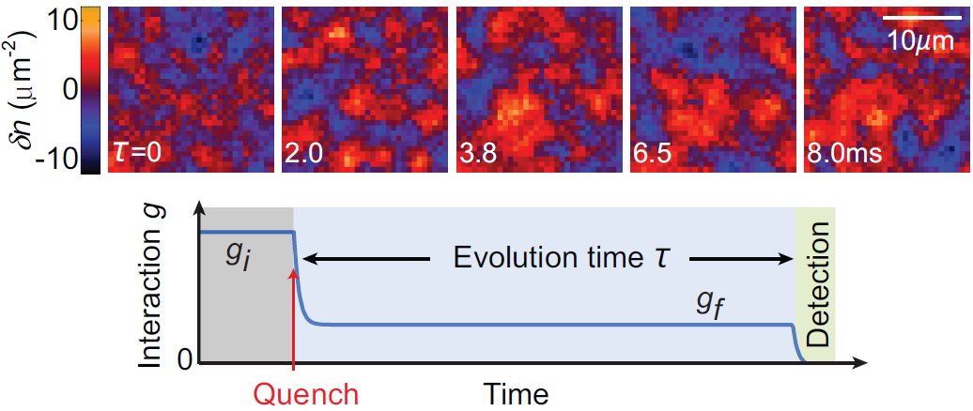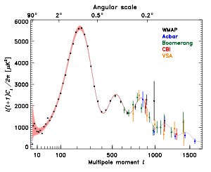

Figure 2: Evolution of density fluctuations in quenched atomic superfluids. By quenching the scattering length, in situ images (left panel) reveal coherent Sakharov oscillations in the density correlations, a phenomenon previously discussed in the evolution of early universe and the cosmic microwave background anisotropy (right panel).

The Chicago group will build on their previous works to identify and investigate the coherent quench dynamics in the weak and strong interaction regime. Based on in situ images of 2D Bose gases, new observables will be extracted, including high-order correlations and potentially, phase fluctuations. In particular, the universality of quantum coherence and the relaxation process will be investigated by studying the dynamics in different regimes. Small amplitude quench dynamics in the weak coupling regime (interaction strength g<<1) can be taken as a benchmark system. Here, the density-density correlations after the quench reveal the propagation of excitations far from equilibrium. The Chicago group will work with the Mueller and Ho groups to extend this model into the spatial correlations in the trap and investigate even higher order correlation functions.
Beyond the small amplitude quench and weak interaction regimes, the Chicago group will work with the Mueller, Sachdev and Ho groups to systematically study the impact on the dynamic structure factor by increasing the quench amplitudes and by driving the system into large or negative scattering lengths. The former will place the system far from equilibrium and the latter explores dynamics when the excitations are no longer described by quasi-particles. Experimentally, the full evolution of density, fluctuations and correlations can be mapped out and compared to calculations.
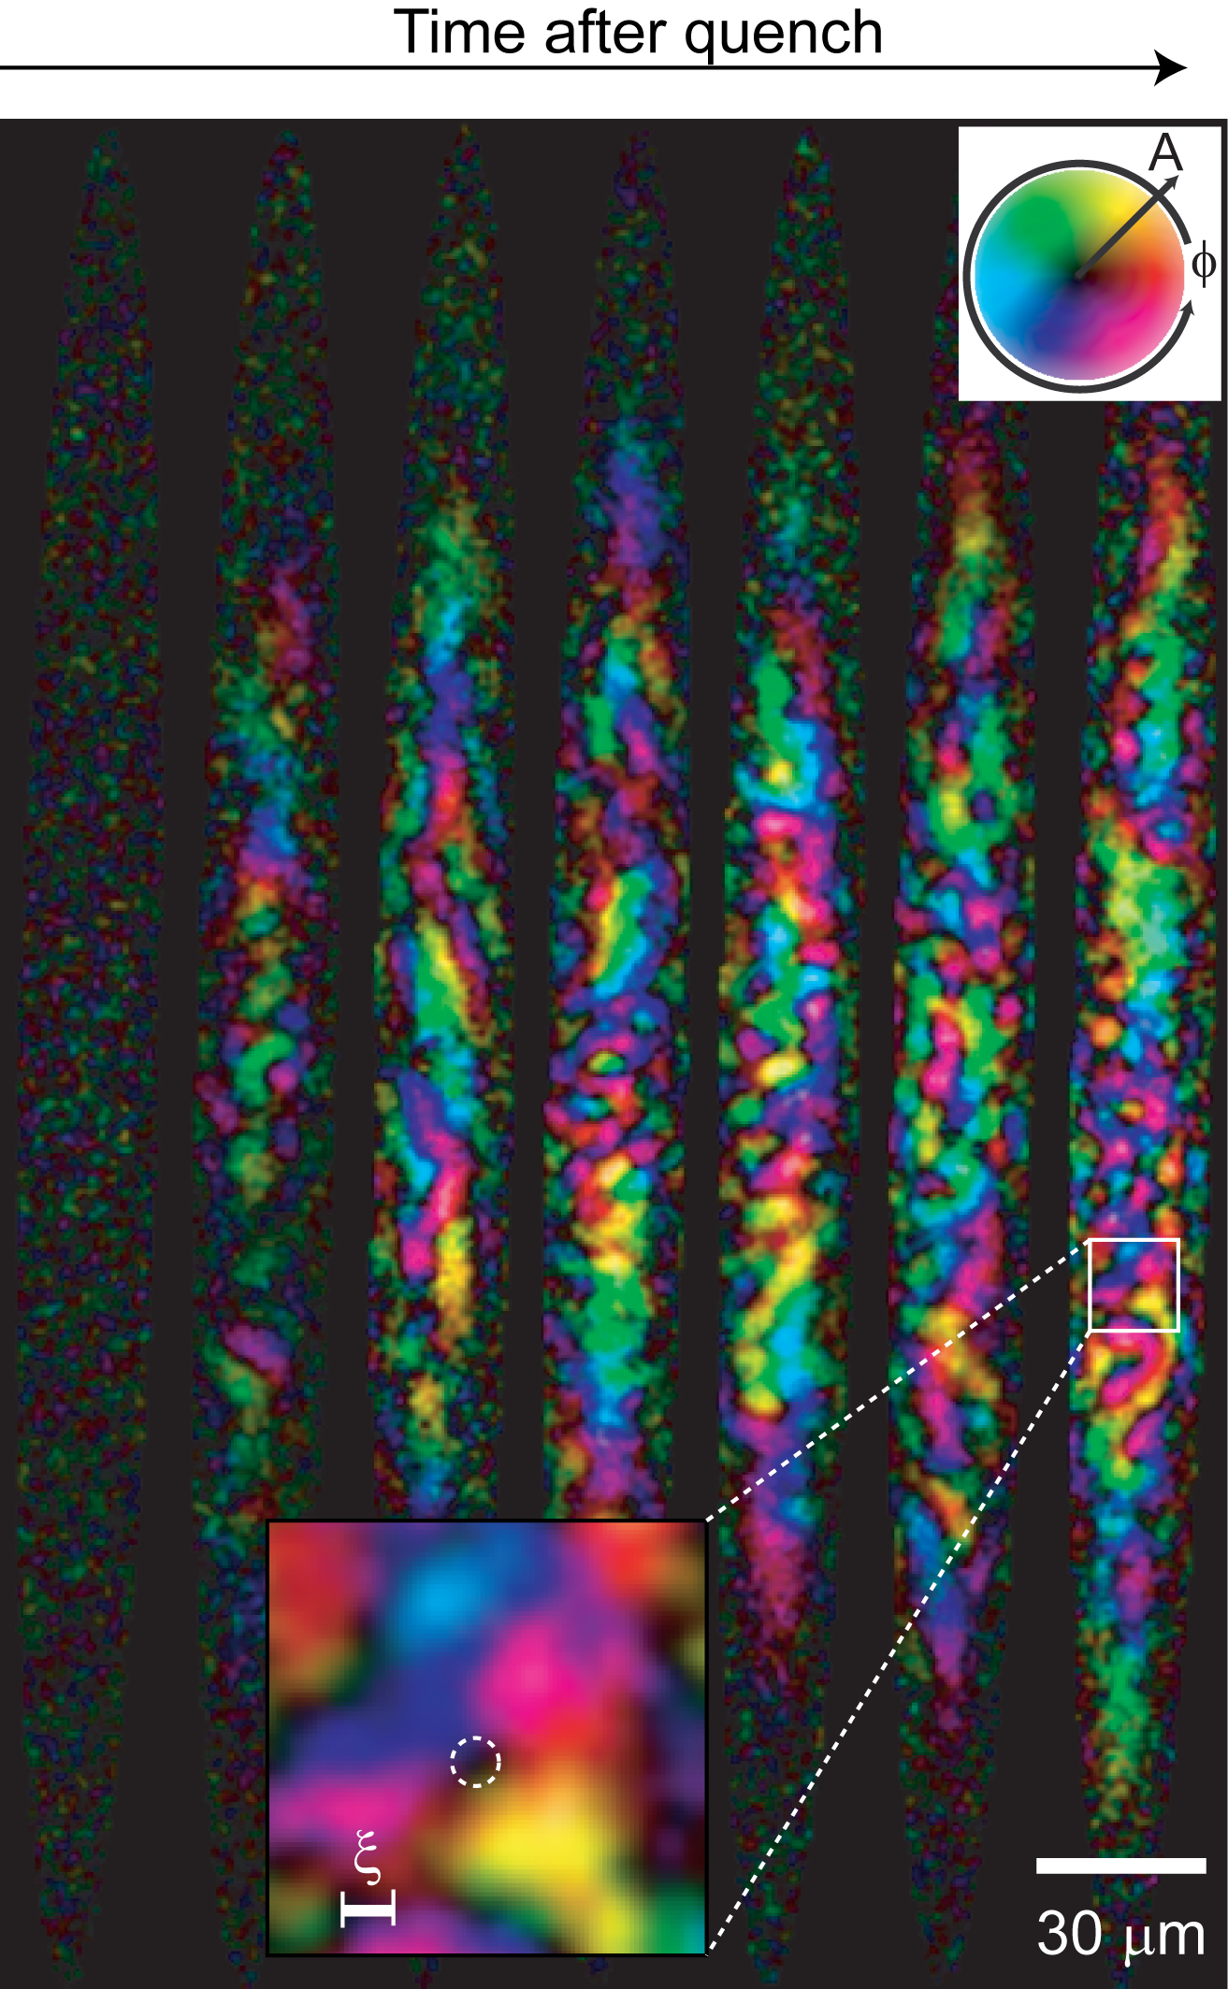
(B) Kibble-Zurek mechanism and topological defects
The Cornell team proposes to study quenched spinor gases in 1D and 2D with a focus on understanding the nucleation and coarsening of ordered domains. The leading paradigm for thinking of this process was developed in the 1970’s and 80’s to understand defect formation in the evolving universe [35] and in continuous phase transitions [36]. Assuming adiabatic evolution of the quenched system (except in the vicinity of the critical point) the K-Z theory predicts a number of universal results, such as a scaling law which relates the density of topological defects produced during the quench to the critical exponents governing the phase transition [37]. While confirmed by experiments on finite temperature phase transitions, the applicability of this model to quantum phase transitions has never been verified. Further, several questions remain unanswered regarding the validity of the K-Z mechanism in inhomogeneous systems, corrections to the scaling laws imposed by finite temperature effects, long-range interactions and strong correlations. The possible existence of universal scaling laws for non-topological excitations (phonons, magnons etc.) that are concomitantly produced during the quench is also an open question.
Figure 3: Topological defect generation in a spinor condensate following a quantum quench. These images show the magnetization density of spinor condensates for variable evolution times after a quench to a ferromagnetic state. Inset: An instance of a spin vortex spontaneously created during the quench. (Adapted from Ref.[29]).
By applying a magnetic field to a ferromagnetic F=1 spinor gas, we can drive a continuous quantum phase transition between a “polar” state with not magnetic degrees of freedom, to a ferromagnetic state (with either XY or Ising symmetry); see Figure 3. Due to the slow relaxation timescales in this system we can track the dynamics and directly measure the time dependence of the local magnetization. We will identify topological defects, and investigate the applicability of scaling laws.

(C) Quench Amplification of Quantum Correlations
Using the same apparatus as 3.1(B), we will study how the spatial structures formed in a quench depend on the quantum correlations in the initial state. The growth of macroscopic order following the quench results from the exponential amplification (inflation) of unstable, gapless modes past the critical point. In a quantum phase transition, these modes are seeded by quantum fluctuations. This presents two important open questions: (i) Can inflation preserve non-classical correlations in the initial, quantum seed? and (ii) What general principles govern the nature of the quantum-to-classical transition whereby the initial quantum seed is amplified to a macroscopic, classical phase? Nascent efforts at answering these questions make it seem likely that there will be experimental signatures in the Cosmic Microwave background (CMB) that can be traced back to quantum correlations in the primordial state of the Universe prior to inflation [38].

We propose seeding the growth of the ferromagnetic domains with specific initial conditions including a thermal gas, a coherent state, a vacuum as well as a squeezed vacuum state [39]. Through measurements of the spatial and temporal correlations of the emergent ferromagnetic state for these different initial conditions, we aim to quantify the robustness of the initial state past inflation. In addition to shedding light on the validity of theoretical efforts probing the physics of the Early Universe, a deeper understanding of inflation in its capacity to amplify weak, quantum effects will also prove a valuable tool for beyond-SQL metrology using quantum many-body systems.

(D) 1D Fermi gas: emergent degrees of freedom
In addition to their technological significance, one dimensional systems (1D) offer a rich and quite special physics. Kinematics is strongly constrained and quantum and interaction effects are amplified. Excitations in one dimension are collective in nature, leading to very peculiar dynamics. For example, according to the universal Luttinger liquid theory describing generic one dimensional interacting systems, transport of spin-1/2 fermions in 1D exhibits a remarkable “spin-charge separation”, where the velocities of spin excitations can differ markedly from charge (i.e. mass) excitations [35]. This fractionalization of excitation which is the rule in 1D rather than the exception has clearly drastic consequences for properties such as thermalization.

We plan to address these issues both on the theoretical and experimental level.
A first step in this direction consists in directly detecting these emergent degrees of freedom. Indeed, although spin-charge separation has been seen in GaAs/AlGaAs heterostructures [41], due to limitations of the system, the expected dramatic dependence on interactions (i.e. the Luttinger parameter) has not been explored. Cold atoms will thus provide a much richer situation to study this physics. On the theoretical side, the equilibrium properties of one dimensional systems can be tackled by controlled methods, both analytical and numerical [40], giving a firm footage on which to address the much uncharted properties of out of equilibrium systems.

The Rice group will conduct these experiments. Atoms will be confined in an array, or bundle, of 1D tubes created by a 2D lattice, as was previously demonstrated [42]. A mesoscopic number of approximately 100 ⁶Li atoms are loaded into each tube, which can be well isolated from one another by applying a strong lattice. Both the sign and strength of the interactions can be controlled via a Feshbach resonance, allowing full control over the Luttinger parameter. Spin and mass excitations can be directly created optically. A laser beam focused on one end of the tube bundle will create mass excitations if detuned far from the two relevant hyperfine sublevels and an electronically excited state, while spin excitations are created if the laser detuning is set in between the two levels. The subsequent evolution can be imaged, yielding spin and mass velocities [42]. Sudden interaction or confinement quenches will also produce spin and mass excitations [43].

The experimental work on the 1D Fermi gas will be complemented by theoretical calculations by the Cornell group (Mueller), the Ohio State group (Ho) using Bethe Ansatz solutions and the Geneva group (Giamarchi) using field theory and numerical methods (DMRG). Conditions for spin-charge separation will be calculated and compared to the measurement. The Ohio State group will also investigate quantum dynamics of 1D systems with fractional charges. It is expected that fractional charge excitations can be created in 1D lattices with alternating hopping, a scenario conducive to quantum information processing. The latter falls neatly connects with our other themes, as controlling dissipation is key to any practical quantum computation.

This work builds on a number of our previous achievements, such as (i) The construction and
characterization of an array of 1D traps containing fermionic Li [44]; (ii) Theoretical modeling
of related 1D systems [45, 46] and dimensional crossovers [47]. The experimental work will
mainly be performed by the Hulet group, while the theoretical work will be done by Giamarchi,
Ho, and Mueller. Ho also plans to look at quenches in 1D models. Since these system are
exactly solvable, there is very good chance to deduce the general principles governing nonequilibrium dynamics in this regime.

2.2. Theme 2: Holographic approach to quantum critical dynamics
Major Questions: How are strong correlations and quantum criticality reflected in non-equilibrium dynamics? What are the paradigms for understanding the kinetics of strongly correlated or critical systems that cannot be described by a Boltzmann equation? To what extent can holographic principles based on quantum gravity be used to describe dynamics near a critical point?

(A) Quantum critical transport of bosons in 2D optical lattices
The Chicago group proposes to measure transport coefficients in a gas of 2D lattice Bosons. In the weakly interacting regime these results can be compared with perturbative calculations. Near the quantum critical point these will be compared to models based on gauge-gravity duality.

The conformal symmetry of 2+1 dimensional quantum critical gas and gauge-gravity correspondence provides a particular simple and universal form of the transport coefficient due to universal scale invariance [48]. A comprehensive overview of the correspondence and its predictions are given in Ref. [49]. In particular, general arguments based on the universal properties of the conformal field symmetry suggests that the dynamics conductivity is predicted to be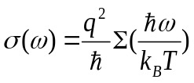[50], where, for cold atom experiments, charge q can be replaced by the atomic mass, and Σ(x) is a universal function.

The Chicago group will perform the measurement on quantum critical transport and collaborate with the Harvard group with the goal to measure the transport coefficients and to test the predictions based on the gauge-gravity duality. Experimentally, cesium atoms prepared near the superfluid-Mott insulator quantum critical point in 2D optical lattices will be prepared at various temperatures [51]. Quantum critical transport will be induced by small modulating of the lattice potential and be monitored by in situ measurement of the atomic density n(x,y,t) and fluctuations δn(x,y,t) after different hold times t after the modulation. Based on the local density and local equilibrium approximation (we expect a hydrodynamic behavior of quantum critical systems), we can fully determine the space-time evolution of the essential thermodynamic variables, eg., chemical potential μ(x,y,t), energy E(x,y,t), and temperature T(x,y,t), as well as the fluxes of the extensive quantities, eg., the density flux J_{n} and the energy flux J_{e} , see Figure 4. Transport properties can thus be extracted from the generic form of transport equations: 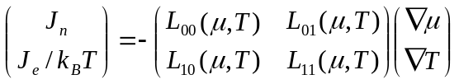, where the transport matrix [L_{ij}] contains the conductivity L₀₀, the thermal conductivity L₀₀, the thermal-electric coefficients L₀₁ and L₁₀. The latter two correspond to Pielter and Seeback effects. Onsager reciprocal relation predicts L₀₁₌ L₁₀.

Determination of the complete transport matrix will reveal a wealth of exciting physics and will also complete and critical test on the Onsager relation and the predictions derived from the gauge-gravity correspondence.

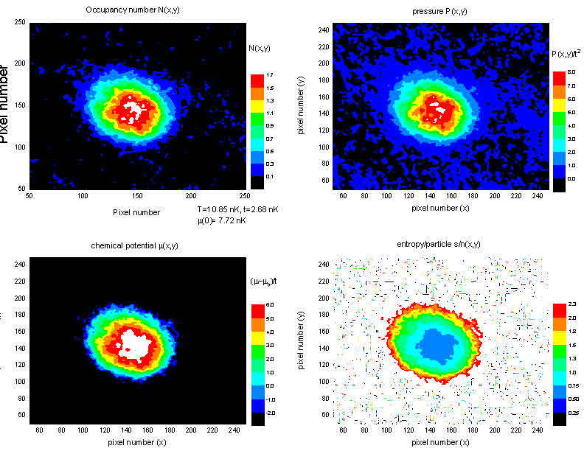
Density n(x,y,t)
Entropy S/N(x,y,t)
Pressure n(x,y,t)
Figure 4: Complete characterization of quantum transport in the critical regime. From in situ images, the Chicago group will map out the full evolution of the thermodynamic quantities in a quantum critical system, and determine the transport properties. Distributions of thermodynamic quantities are derived from the high resolution imaging of the in situ density, fluctuation and correlations of the sample.

(B) Connecting Field-theoretic and Holographic Methods
This work builds on a number of our previous achievements, such as the development of: (i)
holographic descriptions of dynamics near quantum critical points [52], including effective
holographic theories of CFTs relevant to ultracold atom experiments [53]. The next step is to establish a direct link between the weak-coupling field theory, and the holographic results valid for very strong couplings. This is done by a computation [54] of quantities which are amenable to both methods, the operator product expansion coefficients of conserved currents. While not easily measureable, these coefficients allow us to connect the two approaches in a mutual regime of validity. The present computations [54] have been carried out using a 1/N expansion of the field theory, and these will be supplemented by a direct numerical simulation of the multi-point correlators of the field theory. On the holographic side, we have recently obtained new information on sum rules and quasi-normal modes characterizing the response functions [55] which provide additional constraints on the structure of the field theory.

With an improved understanding of the connection between the quantum-critical field theory and the holographic approach, we will also be in a position to use the holographic methods to more completely describe the quantum critical dynamics. The holographic approach can describe the whole dynamical process, from quantum quench to thermalization, within a unified framework. It is easily extended to the non-linear regime, as may be required by the experimental setup. Furthermore, it allows us to address related questions from Theme 1 and Theme 4. The holographic method is amenable to the quench setup of Theme 1, and the time evolution follows from the equations of motion of semi-classical gravity. Within this framework, but also far more generally, it is expected that there will be a close connection between the quench time-evolution and the quasi-normal modes of the quantum critical theory [55, 56]. Uniquely to the holographic method, the same equations describing the short time quantum quench, also yield thermalization and equilibration at long times due to the formation of a horizon in the holographic space [56]. We will study connections between this description of thermalization and the other methods described under Theme 4.

Unitary fermions present another opportunity to explore the connection between field-theoretic and holographic methods. Fermions at unitarity exhibit a large group of symmetry called the Schrodinger's symmetry. This is the nonrelativistic analog of the relativistic conformal algebra. The conformal symmetry enables the application of many techniques often used in conformal field theory. In particular, the short-distance and short-time correlation functions of the unitary Fermi gas are determined by the operator production expansion, in which an important role is played by Tan's contact parameter [57]. The operator product expansion provides a connection between few- and many-body physics of the unitary Fermi gas.

Within holography, the Schroedinger symmetry can be realized as the symmetry of a spacetime called the Schroedinger spacetime [58, 59]. Since operator product expansion is very natural in holography, it may also provide a bridge between field-theoretic and holographic approaches to unitary Fermi gas.

(C) Jet suppression in a 3D unitary Fermi gas
One of the most remarkable displays of universality in physics is the phenomenon of perfect fluidity. Both the quark-gluon plasma (QGP) created at energies of ~1 Gev [60] and the unitary Fermi gas of ultracold atoms at 1 peV [61] have a ratio of shear viscosity to entropy that approaches the lower bound of 1/4π (ħ/k_{B}), predicted by a theory dual to a description of black holes in anti-de Sitter space [62]. The fact that phenomena involving vastly different microscopic physics and occurring at energy scales differing by a factor 10²¹ share common macroscopic properties helps to validate our quest in physics to find general principles underlying complex phenomena. But how far does the analogy between the QGP and the unitary Fermi gas extend?
From the theoretical point of view, the unitary Fermi gas shares many common features with the N=4 supersymmetric Yang-Mills theory, which provides the simplest model for the strongly interacting QGP. Both theories are scale invariant, and both have vanishing bulk viscosity which is a consequence of conformal symmetry. Compared to the QGP, holographic models of the unitary Fermi gas are more rudimentary: existing proposals [63-65] based on the Schroedinger spacetime suffer from an unrealistic equation of state. It is therefore crucial to understand further the analogy between the unitary Fermi gas and the QGP.
One possible venue is the response of the unitary Fermi gas to energetic probes. The dynamical response of the QGP is further probed by jets of hadronic particles that are created in the collision of two heavy nuclei. The propagation of these jets is observed to be suppressed [66,67], again indicating a short mean free path between collisions, but counter to the expectations of asymptotic freedom where the interactions between quarks weakens at high densities. The physics of the QGP at the microscopic scale, such as the dispersion relation and the quasi-particle spectrum, if these concepts even exist in the context of the QGP, is still poorly understood. The experimental investigation proposed here will address these questions for a unitary Fermi gas, which by analogy to the perfect fluid, may help guide our understanding of the QGP.
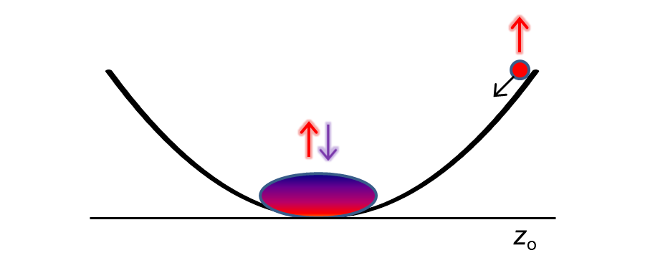
Figure 5. Schematic illustrating jet suppression experiment. A unitary Fermi gas is prepared at the center of the harmonic trap with equal populations of spin-up and spin-down atoms, and with T > T_{c}. A small number of spin-up atoms is displaced a distance z_{o} from the center and released with tunable energy. The opacity is measured as a function of energy.
The Rice group (Hulet) proposes to probe the dynamical response of the unitary Fermi gas using the scheme illustrated in Figure 5, which is similar to the method that the Rice group previously employed to measure the dissipative transport of a Bose-Einstein condensate through disorder [68]. A similar proposal to investigate the dynamics of the QCP with cold atoms was recently analyzed [69]. In our scheme, a pseudo-spin ½ gas of ⁶Li fermions is created at the center of a cigar-shaped harmonic confining potential formed by a single focused infrared laser beam. The spin populations are balanced and a magnetic field is tuned to near the broad Feshbach resonance at 834 G, thus creating a strongly interacting Fermi gas. The temperature may be controlled by evaporation and is adjusted so that the gas is cold with T < T_{F}, where T_{F} ~ 1 μK is the Fermi energy, but not below the superfluid transition temperature of ~0.2 T_{F}. This gas is a strongly-interacting unitary Fermi gas that is a perfect hydrodynamic fluid. A small fraction of this sample is displaced axially from the center of the harmonic trap using a repulsive light sheet made from a cylindrically focused laser beam at 532 nm. (The Rice group previously used a similar configuration to displace matter-wave solitons in a harmonic trap [70]). One of the spin-states of this small sample is then removed using resonant light scattering, leaving the sample in a single, non-interacting spin-state that is displaced from the original strongly-interacting unitary gas at the center (see Fig. 3). The spin-polarized sample is then released from various starting positions z_{o}, so that it gains kinetic energy E = ½mω_{z}²z_{o}² before interacting with the stationary unitary gas. The opacity of the unitary gas to the isolated spins in the moving sample will be determined from N(E), the fraction of atoms transmitted through the unitary gas. N(E) depends on the dynamical response at energy E and is analogous to the momentum dependence of the opacity of the QGP. E can be varied by adjusting the initial displacement z_{o} and the harmonic frequency ω_{z}. Given a range of z_{o} = 0.1 to 1 mm and ω_{z} = (2π) 10-100, allows E to be varied between 0.01 E_{F} to 100 E_{F}, which is sufficient to probe the long-wavelength collective response of the system at low energy, and the high energy regime where E >> E_{F}. This experiment is an extension of a related experiment probing non-equilibrium dynamics after collisions of two fully-polarized gases [71].
A Fermi gas at unitarity is an example of a strongly interacting theory, where usual perturbative techniques fail. Despite this fact, one can make some exact statements about this Fermi gas. First, the long-distance dynamics of the gas is described by a hydrodynamic theory (either superfluid hydrodynamics or normal hydrodynamics). Second, the short-distance and short-time correlation functions are determined by the operator production expansions, where an important role is played by Tan's contact parameter. We would like to understand how the two regimes are connected to each other.
Fermions at unitarity exhibit a large group of symmetry called the Schrodinger's symmetry. This is a nonrelativistic analog of the relativistic conformal algebra. Within the theory of unitary fermions, one can determine the notions of primary operators. The operator product expansions between the operators are the most direct connections between many- and few-body physics of a unitary gas. We want to investigate if the knowledge of the OPEs constraints the real-time dynamics of the gas.
Holography provides simple models of nonequilibrium physics. In some models, one can
finely tune some quasinormal modes to be near zero. We want to understand if the resulting
dynamics resemble one described by a time-dependent Ginsburg-Landau equation.

2.3. Theme 3: Entropy management and adiabaticity
Major Questions:
What are the limits to adiabaticity for many-body systems? How can one use spatial anisotropies to sequester entropy, thereby allowing the production of lower temperatures and exotic many-body states? How do the existence of local and global conservation laws influence transport of energy, entropy and spin in a many-body system?

(A) Limits of adiabaticity for lattice bosons
Low entropy is required to realize new quantum phases of matter. For instance, magnetic ordering of a spin ½ system, in the classical limit, requires the entropy per particle to be less than k_{B} ln2. The lowest entropies are usually created in systems which have an energy gap (e.g. band insulator) because at low temperatures excitations are suppressed by an exponentially small Boltzmann factor. A promising strategy is therefore to prepare low entropy states in a situation which has an energy gap, but then ramp adiabatically to the Hamiltonian of interest which usually has low-lying excitations (e.g. spin waves). During the ramp, the temperature is reduced by a factor which is approximately the energy gap over the characteristic energy of the low-lying excitations. The MIT group has recently demonstrated how adiabatic cooling can reduce the temperature of a Mott insulator into the picokelvin range [72].

Direct cooling of “spinful” states to such low temperatures has not been possible so far. Therefore, there is huge interest in developing adiabatic cooling schemes. This will give access to a host of new quantum states. The fundamental challenge for such cooling schemes is that full adiabaticity requires the ramp rate to be smaller than the energy spacing of the lowest excitations.

For many interesting systems this spacing becomes very small – by principle, because it is the near degeneracy of energy levels which allows interactions to create strongly correlated quantum phases. For instance, the degeneracy of the Landau levels for non-interacting electrons gives rise to the fractional quantum Hall effect. Therefore, it is fundamentally impossible to maintain adiabaticity during the whole ramp, and the process is governed by non-equilibrium dynamics which we propose to study.

This theme naturally connects with other themes in our proposal. The opposite limit of a quasi-adiabatic ramp is a sudden ramp or quench (theme 1). Adiabaticity breaks down at quantum critical points (theme 3). Finally, due to the near-integrability, the fastest adiabatic ramps are likely to occur in weakly coupled 1D systems, connecting with the issues in theme 4.

These studies are also directly relevant to adiabatic quantum computation, where the unknown ground state of a Hamiltonian is prepared via an adiabatic ramp from the initialized state of the qbits [73].
The MIT group will implement adiabatic cooling for a two-component Bose system in a Mott insulator state. For two particles per site and small interspecies interaction, the ground state is gapped with one particle each per site. For larger interspecies interaction, the ground state is an xy ferromagnet [74]. The interspecies scattering length can be varied using a spin-dependent lattice. For fermions, one can use a superlattice to double the number of lattice sites and connect a band insulator to a Mott insulator with an antiferromagnetic ground state [75]. The magnetic ordered state can be detected by imaging the spin fluctuations as in our recent work [24]. Antiferromagnetic ordering suppresses fluctuations, ferromagnetic ordering enhances them.

(B)Entropy generation by light scattering
Light plays a crucial role in our experiments: it is used for laser cooling and optical pumping, it provided potentials in the form of optical dipole traps and optical lattices and it is a tool to prepare and probe atoms in a quantum state-specific way. However, it is also source of heating due to inevitable spontaneous emission.

The MIT group proposes to investigate what happens when photon are scattered by atoms in optical lattices, and how entropy is created. This study is motivated by understanding the fundamental limitations of manipulating atoms with laser light, but also by the fact that light scattering is a precision tool to create quasiparticles far away from thermal equilibrium. By studying those quasiparticles and their decay, we can reveal the quantum dynamics of entropy creation. For instance, when light scattering promotes an atom to an excited band, the quasiparticle may be metastable and the “damage” to the many-body state is limited. However, when this energetic quasiparticle decays into many low-lying excitations in the lowest band, then much more entropy is created [76]. Experimentally, we can monitor heating by temperature measurements, and quaisparticles in excited bands can be observed using standard band-mapping techniques.

(C)Spin transport in a multi-component quantum gas
Complementing the studies of particle and energy transport by the MIT group, the Cornell team proposes to study the dynamics of spin transport in multicomponent quantum gases. The main thrusts of our investigations are (i) the influence of spin degrees of freedom in determining timescales of thermalization in 1D systems and (ii) the role of topologically conserved quantities in suppressing damping and dissipation of spin transport.

Our studies on this theme include experiments on both F=1 gases of ⁸⁷Rb and ⁷Li. While these gases exhibit qualitatively similar interactions, the relevant coupling strengths differ by around two orders of magnitude, giving us a means of pinpointing the role of the spin-charge coupling. For the first set of studies, these gases will be confined in arrays of 1D traps and initialized in highly non-equilibrium motional and spin states through a combination of Bragg scattering and optical imprinting of spin textures. For scalar Bose gases, it has been shown that similarly prepared isolated 1D systems do not seem to thermalize on experimentally relevant timescales [77]. Opening up the spin degree of freedom offers a discrete, theoretically tractable method to lift integrability. The ensuing thermalization dynamics in this system allows a systematic study of the rich interplay between spin exchange, the coupling between different collective excitations and the dimensionality of the system [78, 79].

One of the main roadblocks to understanding the non-equilibrium dynamics of isolated systems is the constraint imposed by numerous conserved quantities inherent to the many-body system. While one normally encounters such symmetries in the form of number, energy or spin conservation, an equally important consideration in low-dimensional quantum systems is the presence of topologically conserved quantities (eq. vortices). Our second series of experimental studies aim to isolate the role of such topological defects in preserving and stabilizing non-equilibrium many-body states. In particular, we propose to study the effect of optically imprinted spin vortices on spin currents in 2D spinor gases. In addition to a deeper understanding of spin currents and their dynamics (for example, in spintronic applications), these experiments are also motivated by the observation of long-lived spontaneously organized spin textures in quantum degenerate spinor gases arising from the competition between long-range dipolar interactions and short-range ferromagnetic interactions [80-82].

(D)Modeling entropy production and control
Using exact knowledge of the single-tube spectrum, the Ho group will study entropy production in arrays of tubes as their coupling is changed. This group will also study kinetics of Bose lattice gases in the ultracold regime, the spatial sequestration of entropy, models of novel cooling techniques, and spin dynamics in isolated clusters. The Mueller group will produce and study analogs of Boltzmann equations which are applicable near the superfluid Mott transition, and which include the relevant spinor degrees of freedom. They will use these to model experiments and propose protocols. They will also continue their work within the Bogoliubov approach, asking how the nonequilibrium physics can be probed by techniques such as RF spectroscopy. The Vengalattore group will use semiclassical approximations (truncated Wigner methods and generalizations) to model the experiments

2.4. Theme 4: Quantum origin of thermalization
Major Questions:
How does integrability influence transport properties of a many-body system? How does the coupling between motional and spin degrees of freedom affect thermalization of a many-body system? What is the nature of prethermalized phases (where the many-body system reaches a quasi-steady state that differs from thermodynamic predictions)? Are there universal scaling laws that govern such prethermalized phases of matter?

(A) Breaking of Integrability in a strongly interacting 1D Fermi gas
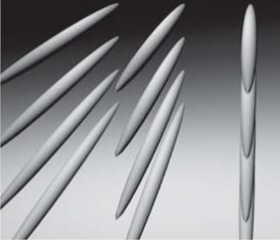
Integrable systems have an important role in developing our understanding of how quantum systems thermalize. Transport in one dimension is controlled for integrable models by the large number of conservation laws constraining the dynamics, but more generically by the collective nature of the excitations in one dimension [83, 84]. Since integrable systems are not ergodic, their dynamics occur in only a sub-space of the full system. Consequently, the system may never find its true ground state, and hence, fails to thermalize. A dramatic example of a fully integrable system, realized with cold atoms, are 1D hard-core bosons [77]. A “Newton’s Cradle” was created by setting the atoms in motion along the 1D tube axis and observing the subsequent momentum distribution. Remarkably, the gas failed to equilibrate during a time over which each atom underwent hundreds of collisions. One way to understand this result is that integrable quantum many-body systems have well-defined quasiparticle excitations that interact only elastically, without the possibility of dissipation [33]. Although the integrable system is unable to relax to a thermal distribution, it has been shown by the maximum entropy principle embodied by the generalized Gibbs ensemble that it will reach an equilibrium state, albeit far from thermal [85].
t
t
Figure 6. The tunneling energy, t, between the tubes created by a 2D lattice may be tuned by adjustment of the lattice depth. The crossover between isolated 1D tubes to a 2D or 3D geometry may be tuned continuously.

What happens as integrability is gradually lifted? Is there a smooth or sharp crossover between these dramatically different equilibrium states? It is known that the boundary between integrable and nonintegrable systems is associated with quantum chaos [86] – how is chaos in this situation manifested? What is the role played by quantum coherence?
We propose to explore the crossover of an integrable system of spin-1/2 fermions in isolated 1D wires, to a nonintegrable system arising from weakly coupling the wires. The experimental work will be performed at Rice University, where a 1D fermion experiment has already produced results [20]. The coupling between tubes in the 2D optical lattice is readily controlled, enabling the 1D system to evolve into either 2D or 3D depending on the strengths of the lattice beams. We propose to quantify the resulting dynamics by releasing the atoms in the quasi-1D system by suddenly removing either a confining crossed beam, or by performing a sudden quench in the confining potential, see Figure 6.
Such a crossover is directly relevant to a host of physical systems in the condensed matter context, such as organic superconductors, which can exhibit a dimensional crossover between the 1D and higher dimensional world. This can lead to a deconfinement of the collective excitations which has drastic consequences for the linear response transport [87].
We plan to theoretically study coupled fermionic chains and the consequences of the nature of the excitations for the transport and thermalization. Field theory (bosonization) gives a good way to attack this problem. However, the coupling between the chains is a relevant perturbation for which suitable approximations must be found. We plan to combine the analytic solution with numerical ones such as the Density Matrix Renormalization group (DMRG) technique. Such a technique indeed allows the study of real-time dynamics, and is thus ideally suited for this question. It is limited by efficiency, so far, to one dimensional systems, but various techniques to extend the implementation efficiently to higher dimensions have been recently studied in connection with quantum information theory [88]. Combined with the field theory it has proven to be a very efficient way to tackle the equilibrium properties of quasi-one dimensional systems and we anticipate a similar fruitful use for the out of equilibrium questions at hand.
(B) Thermalization of quantum gases during ramp
The MIT group will experimentally study how bosons and fermions thermalize in 1D tubes, when the Hamiltonian is swept or quenched between a gapped phase (e.g. band insulator) and a spin ordered phase. This study is related to our study of the limits of adiabatic ramps described in theme 3.

(C) Thermalization of atomic gases with internal (spin) degrees of freedom
Here, the experiments led by Mukund Vengalattore, focus on the thermalization of atomic gases with internal (spin) degrees of freedom. The goals are (i) to develop a broad understanding of thermalization in many-body systems with multiple order parameters, (ii) to study regimes of dimensionality, temperature and interaction strength for which these spinor gases exhibit a novel ‘prethermalized; phase [89] characterized by quasi-steady state distributions that differ from thermodynamic predictions and (iii) to establish a quantitative methodology for the extraction of universal parameters that govern the behavior of such prethermalized phases of matter.

These experiments build upon our previous work in identifying a quantum phase transition (QPT) between a spin nematic and ferromagnetic phase in ultracold F=1 spinor gases of ⁸⁷Rb, our identification of ⁷Li as a spinor gas that exhibits a strong ‘spin-charge’ coupling and our ability to perform time resolved, quantum-limited measurements of the macroscopic magnetic order in these gases.

Further, based both on experimental and theoretical investigations of quenched spinor gases, we have identified a novel prethermalized regime in quenched quantum degenerate spinor gases [89]. In this regime, the system is found to evolve into a quasi-stationary steady state characterized by correlations that differ from the predictions of thermodynamics. Such prethermalized states have previously only been found in low dimensional, integrable systems. The occurrence of such phases in higher dimensional, non-integrable systems offers an opportunity to study prethermalization in a system capable of controlled changes of temperature, dimensionality and spin content while still remaining amenable to theoretical modelling. In addition to understanding the origin and robustness of such phases, one of the most important questions about prethermalized phases is the possibility of universal laws (similar to equilibrium statistical mechanics) that govern these quasi-stationary phases (see Figure 7).

Using measurements of the macroscopic observables (magnetization density, spin correlation functions etc.) and spectroscopic measurements of the collective excitations in this gas, we propose to conduct a comprehensive mapping of the dynamical behavior of these spinor gases in the vicinity of the QPT. These measurements will inform a quantitative methodology for the extraction of universal parameters that govern the prethermalized phase, thereby laying the groundwork for theories that seek to connect the microscopic interactions in this gas to the macroscopic dynamical behavior of similar many-body systems.

The theory groups of Ho, Mueller and Giamarchi plan to study these phenomena in various dimensions. In the case of 1d, the Bethe Ansatz solutions will help to extract precise results, even though the generality of these results might be affected by integrability of the system. The Vengalattore group will use semiclassical approximations (truncated Wigner methods and generalizations) to model the experiments on prethermalization.
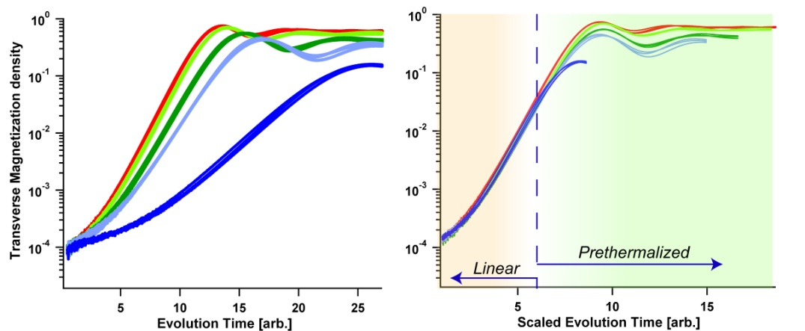

Figure 7: Left: The growth of the magnetization density of a spinor gas following a rapid quench into the ferromagnetic state, for different interaction strengths. An initial ‘inflationary’ period of exponential growth is followed by a ‘prethermalized’ regime [89]. Right: The same data when rescaled using Bogoliubov theory, clearly shows that the inflationary period obeys a scaling collapse onto a single functional form. In contrast, a similar scaling law for the prethermalized regime is, as yet, unknown. Through comprehensive measurements of the prethermalized regime for different dimensionalities, interaction strengths and quench rates, we seek to uncover similar universal laws for the prethermalized phase.

2.5. Summary
We have identified a set of fundamental questions on paradigms of non-equilibrium many-body phenomena. Our ambitious scientific agenda addresses these questions through theoretical and experimental studies on quench dynamics, quantum criticality, entropy control and the quantum origins of thermalization in many-body systems. Our team is composed of pioneers who have made seminal contributions to both the experimental and theoretical advances in these areas. The program has been formulated to develop a scientific conduit from the verifications of abstract theoretical notions (such as the AdS/CFT correspondence, Quantum criticality and the Eigenstate Thermalization Hypothesis) to applications of immediate scientific and technological benefit (including materials design, quantum sensor technology and spintronics). This agenda will broadly impact diverse areas of science ranging from the quantum implications of inflationary Cosmology to the microscopic mechanisms at the heart of the Quark/Gluon plasma.

3. Project Schedule, Milestones and Deliverables
Year 1
Milestone | Theme | Investigator(s)
Determination of distribution of thermodynamic variables in a system near thermodynamic equilibrium | 1 | Chin, Mueller and Ho
Explore quench and Raman methods for creating spin-dependent excitations in 1D | 1 | Hulet
Ramping in one dimensional Luttinger liquid/Mott insulator | 1 | Giamarchi
Experimentally measure the heating in a Bose lattice gas from controlled amounts of light scattering | 3 | Ketterle
Year 2
Separately measure spin and “charge” velocities in 1D Fermi gas | 1 | Hulet
Develop energy-tunable, spin-dependent collider to study transport in unitary Fermi gas | 2 | Hulet
Determination of time-dependent structure function following quench of quantum critical Bose gas | 2 | Chin, Mueller, Ho and Sachdev
Count topological defects during quench of ferromagnetic F=1 spinor gas and compare with K-Z model | 1 | Vengalattore and Mueller
Create and characterize quasiparticles in a bosonic superfluid and Mott insulator via light scattering | 3 | Ketterle
Model the heating process in optical lattices | 3 | Mueller and Ho
Year 3
Measure time dependence of structure function following quench of Bose lattice gas into critical regime | 1 | Chin
Determine energy-dependent opacity of unitary Fermi gas; compare with quark-gluon plasma and dual gravity theory | 2 | Hulet, Dam Son
Use holographic method to predict static structure function and compare with experiment | 2 | Chin and Sachdev
Measurements of spin correlation functions of spinor condensates in the prethermalization regime and the extraction of scaling laws governing the dynamical evolution of the system in this regime. | 3 | Vengalattore and Mueller
Produce thermal, coherent, vacuum, and squeezed states in a ferromagnetic F=1 spinor gas | 3 | Vengalattore
Adiabatic cooling of bosons in optical lattices by ramping from a paired phase to a ferromagnetic phase | 3 | Ketterle
Analytical and numerical study of the transverse coherence in a set of coupled one dimensional fermionic chains. | 4 | Giamarchi
Measure 1D expansion dynamics of arrays of 1D tubes of fermions, as function of tube coupling | 4 | Hulet

Option Period (2017~2018)
Year 4
Milestone | Theme | Investigators
Test on the steepest entropy ascent hypothesis or the Onsager relation in non-equilibrium thermodynamics by measuring entropy in a quenched quantum gas. | 1 | Chin, Mueller and Ho
Measure non-classical correlations following quench of a F=1 spinor gas | 1 | Vengalattore
Adiabatic cooling of fermions in optical lattices by ramping from a band insulator to a Mott insulator | 3 | Ketterle
Elucidate connections between loss of integrability and manifestations of quantum chaos | 4 | Hulet, Ho, Mueller
Observe and model decay of helical spin-textures generated by optical imprinting/Bragg scattering on a quasi-1D Bose gas | 3 | Vengalattore, Mueller
Produce a quantum Boltzmann equation which describes kinetics near the superfluid-Mott transition | 4 | Mueller, Giamarchi and Ho

Year 5
Observe and predict evolution of spin-charge separation as coupling between tubes is introduced | 1 | Hulet
Develop a new paradigm to describe HEP and gravitational systems based on quantum critical transport and quantum critical quench of atomic quantum gases. | 2 | Chin, Sachdev and Dam Son
Measurements of non-classical correlations during the inflation past a quantum quench, and corrections to the Kibble-Zurek scaling imposed by finite temperature and long-range interactions | 1 | Vengalattore
Extraction of scaling laws governing the thermalization behavior of magnetic gases in the regime of strong interactions and finite temperature | 4 | Vengalattore

References
[1] Ge, H., & Qian, H. (2010). Non‐equilibrium phase transition in mesoscopic biochemical
systems: from stochastic to nonlinear dynamics and beyond. Journal of the Royal
Society Interface, 8, 107‐116.
[2] Qian, H. (2006). Open‐System Nonequilibrium Steady State: Statistical
Thermodynamics, Fluctuations, and Chemical Oscillations. Journal of Physical
Chemistry B, 110, 150603‐15074.
[3] Goulielmakis, E., Yakovlev, V. S., Cavalieri, A. L., Uiberacker, M., Pervak, V., Apolonski,
A.,et al. (2007). Attosecond Control and Measurement: Lightwave Electronics. Science,
317, 769‐775.
[4] Chang, D. E., Sorensen, A. S., Demler, E. A., & Lukin, M. D. (2007). A single‐photon
transistor using nanoscale surface plasmons. Nature Physics, 3, 807‐812.
[5] Lounis, B., & Orrit, M. (2005). Single‐photon sources. Reports on Progress in Physics, 68,
1129.
[6] Fushman, I., Englund, D., Faraon, A., Soltz, N., Petroff, P., & Vuckovic, J. (2008).
Controlled Phase Shifts with a Single Quantum Dot. Science, 9, 769‐772.
[7] Fritz, L., Schmalian, J., Muller, M., & Sachdev, S. (2008). Quantum critical transport in
clean graphene. Physical Review B, 78, 085416.
[8] Gian Paolo Beretta. (1987). Quantum thermodynamics of nonequilibrium. Onsager
reciprocity and dispersion-dissipation relations, Foundations of Physics, 17, 365-381
[9] Lars Onsager. (1931). Reciprocal Relations in Irreversible Processes. I., Phys. Rev. 37, 405–
426
[10] Sergio Bordel. (2011). Non-equilibrium statistical mechanics: partition functions and
steepest entropy increasem, J. Stat. Mech. P05013.
[11] J. M. Deutsch. (1991). Quantum statistical mechanics in a closed system, Phys. Rev. A 43,
2046.
[12] Chen-Lung Hung, Xibo Zhang, Nathan Gemelke, Cheng Chin. (2010). Slow Mass Transport and Statistical Evolution of An Atomic Gas Across the Superfluid-Mott Insulator Transition, Phys. Rev. Lett.104.160403.
[13] Chen-Lung Hung, Victor Gurarie, Cheng Chin. (2012). From Cosmology to Cold Atoms: Observation of Sakharov Oscillations in Quenched Atomic Superfluids, arXiv:1209.0011.
[14] Xibo Zhang, Chen-Lung Hung, Shih-Kuang Tung, Cheng Chin. (2012). Observation of Quantum Criticality with Ultracold Atoms in Optical Lattices, Science 335, 1070.
[15] Giamarchi, T. (2004). Quantum physics in one dimension, Oxford University press.
[16] Cazalilla, M.A., Citro, R; Giamarchi, T., Orignac, E, Rigol, M., (2011), One dimensional bosons: From condensed matter systems to ultracold gases, Review of Modern Physics,, 83, 1405.
[17] Mitra A., Giamarchi T. (2012). Thermalization and dissipation in out of equilibrium quantum systems: A perturbative renormalization group approach, Physical Review B, 85, 075117.
[18] K.E. Strecker, Guthrie B. Partridge, Andrew G. Truscott & Randall G. Hulet. (2002). Formation and Propagation of Matter Wave Soliton Trains, Nature 417, 150.
[19] D. Dries, S. E. Pollack, J. M. Hitchcock, R. G. Hulet. (2010). Dissipative Transport of a Bose-Einstein Condensate, Phys. Rev. A 82, 033603.
[20] Yean-an Liao, Ann Sophie C. Rittner, Tobias Paprotta, Wenhui Li, Guthrie B. Partridge, Randall G. Hulet, Stefan K. Baur, Erich J. Mueller. (2010). Spin-Imbalance in a One-Dimensional Fermi Gas, Nature 467, 567
[21] S. Inouye, M.R. Andrews, J. Stenger, H.-J. Miesner, D.M. Stamper-Kurn, and W. Ketterle.
(1998). Observation of Feshbach resonances in a Bose-Einstein condensate, Nature 392, 151.
[22] H.-J. Miesner, D.M. Stamper-Kurn, M.R. Andrews, D.S. Durfee, S. Inouye, and W. Ketterle.
(1998). Bosonic stimulation in the formation of a Bose-Einstein condensate, Science 279,
1005.
[23] J.K. Chin, J.M. Vogels, and W. Ketterle, Amplification of Local Instabilities in a Bose-
Einstein Condensate with Attractive Interactions. (2003). Phys. Rev. Lett. 90, 160405.
[24] C. Sanner, E.J. Su, A. Keshet, W. Huang, J. Gillen, R. Gommers, and W. Ketterle, Speckle
Imaging of Spin Fluctuations in a Strongly Interacting Fermi Gas. (2011). Phys. Rev. Lett.
106, 010402.
[25] P. Medley, D.M. Weld, H. Miyake, D.E. Pritchard, and W. Ketterle. (2011), Spin gradient
demagnetization cooling of ultracold atoms, Phys. Rev. Lett. 106, 195301.
[26] M. Vengalattore, S. R. Leslie, J. Guzman, and D. M. Stamper-Kurn. (2008). Spontaneously modulated spin textures in a dipolar spinor BEC, Phys. Rev. Lett. 100, 170403.
[27] S. Natu, K. Hazzard and E. Mueller. (2011). Local Versus Global Equilibration near the Bosonic Mott-Insulator–Superfluid Transition, Phys. Rev. Lett. 106, 125301.
[28] Theja N. De Silva, and Erich J. Mueller. (2006). Density profiles of an imbalance trapped Fermi gas near a Feshbach resonance, Phys. Rev. A 73, 051602(R) .
[29] L.E. Sadler, J. M. Higbie, S. R. Leslie, M. Vengalattore and D. Stamper-Kurn. (2006). Spontaneous symmetry breaking in a quenched ferromagnetic spinor Bose condensate, Nature 443, 312.
[30] Erich J. Mueller. (2005). Wigner Crystallization in inhomogeneous one dimensional wires, Phys. Rev. B 72, 075322.
[31] Stefan S. Natu and Erich J. Mueller, Spin waves in a spin-1 Bose gas. (2010). Phys. Rev. A 81, 053617.
[32] Iacopo Carusotto and Erich J. Mueller, Imaging of spinor gases. (2004). J Phys. B: At. Mol. Opt. Phys. 37, S115.
[33] A. Polkovnikov, K. Sengupta, A. Silva, M. Vengalattore. (2011). “Colloquium: Nonequilibrium dynamics of closed interacting quantum systems”, Rev. Mod. Phys. 83, 863.
[34] Hung, C.‐L., Gurarie, V., & Chin, C. (2012). From Cosmology to Cold Atoms: Observationof Sakharov Oscillations in Quenched Atomic Superfluids. arXiv:1209.0011.
[35] T. W. B. Kibble. (1976). Topology of cosmic domains and strings, J. Phys. A 9, 1387.
[36] W. H. Zurek. (1985). Cosmological experiments in superfluid helium?, Nature 317, 505.
[37] J. Dziarmaga. (2010). Dynamics of a quantum phase transition and relaxation to a steady
state. Adv. Phys. 59, 1063.
[38] C. Armandariz-Picon, E. A. Lim. (2003). Vacuum choices and the predictions of inflation.
JCAP 0312, 006.
[39] C. D. Hamley, C. S. Gerving, T. M. Hoang, E. M. Bookjans & M. S. Chapman. (2012).
Nature Phys. 8, 305.
[40] Thierry Giamarchi, “Quantum Physics in One Dimension” (Oxford University Press,
Oxford, 2003).
[41] O. M. Auslaender, H. Steinberg, A. Yacoby, Y. Tserkovnyak, B. I. Halperin, K. W.
Baldwin, L. N. Pfeiffer, and K. W. West. (2005). Spin-Charge Separation and Localization
in One Dimension, Science 308, 88.
[42] Yean-an Liao, Ann Sophie C. Rittner, Tobias Paprotta, Wenhui Li, Guthrie B. Partridge,
Randall G. Hulet, Stefan Baur, and Erich J. Mueller. (2010). Spin-Imbalance in a One-
Dimensional Fermi Gas, Nature 467, 567.
[43] G. Xianlong. (2010). Effects of interaction and polarization on spin-charge separation: A
time-dependent spin-density-functional theory study”, Phys. Rev. B 81, 104306.
[44] Liao, Y.‐A., Rittner, A. S., Paprotta, T., Li, W., Partridge, G. B., Hulet, R. G. (2010).
Spin‐Imbalance in a One‐Dimensional Fermi Gas. Nature, 467, 567.
[45] Guan, X. H.‐L. (2011). Quantum Criticality of 1D Attractive Fermi Gas. Physical Review
A, 84, 023616.
[46] Zhou, Q., & Ho, T.‐L. (2010). Signature of Quantum Criticality in the Density Profiles of
Cold Atom Systems. Physical Review Letters, 105, 245702.
[47] Cazalilla, M. A., Ho, A. F., & Giamarchi, T. (2006). Deconfinement and cold atoms in
optical lattices. International jornal of modern physics B, 20, 5169‐5178.
[48] Christopher P. Herzog, Pavel Kovtun, Subir Sachdev, and Dam Thanh Son. (2007).
Quantum critical transport, duality, and M theory, Phys. Rev. D 75, 085020
[49] S. Sachdev. (2012). Annual Review of Condensed Matter Physics 3, 9
[50] Kedar Damle and Subir Sachdev. (1997). Non-zero temperature transport near quantum
critical points, Phys. Rev. B 56, 8714.
[51] Xibo Zhang, Chen-Lung Hung, Shih-Kuang Tung, Cheng Chin. (2012). Observation of
Quantum Criticality with Ultracold Atoms in Optical Lattices, Science 335, 1070
[52] Sachdev, S. (2012). What can gauge‐gravity duality teach us about condensed matter
physics? Annual Review of Condensed Matter Physics, 3, 9.
[53] Myers, R.C., Sachdev, S, and Singh A. (2011). Holographic quantum critical transport
without self‐duality Physical Review D, 83, 066017.
[54] D. Chowdhury, S. Raju, S. Sachdev, A. Singh, and P. Strack, Multipoint correlators of
conformal field theories: implications for quantum critical transport, arXiv:1210.5247
[55] W. Witczak-Krempa and S. Sachdev, The quasi-normal modes of quantum criticality,
arXiv:1210.4166 .
[56] M. J. Bhaseen, J. P. Gauntlett, B. D. Simons, J. Sonner and T. Wiseman, Holographic
Superfluids and the Dynamics of Symmetry Breaking, arXiv:1207.4194.
[57] D. T. Son and E. G. Thompson. (2010). Short-distance and short-time structure of a unitary
Fermi gas. Phys. Rev. A 81, 063634
[58] D. T. Son. (2008). Toward an AdS/cold atoms correspondence: A geometric realization of
the Schrödinger symmetry. Phys. Rev. D 78, 046003.
[59] K. Balasubramanian and J. McGreevy. (2008). Gravity Duals for Nonrelativistic Conformal
Field Theories. Phys. Rev. Lett 101, 061601.
[60] B. V. Jacak and B. Müller. (2012). The Exploration of Hot Nuclear Matter. Science 337,
310
[61] C. Cao, E. Elliott, J. Joseph, H. Wu, J. Petricka, T. Schäfer, J. E. Thomas. (2011). Universal
Quantum Viscosity in a Unitary Fermi Gas, Science 331, 58.
[62] P. K. Kovtun, D. T. Son, A. O. Starinets. (2005). Viscosity in Strongly Interacting Quantum
Field Theories from Black Hole Physics, Phys. Rev. Lett. 94, 111601.
[63] C. P. Herzog, M. Rangamani, S. F. Ross. (2008). Heating up Galilean holography. J.H.E.P.
0811, 080.
[64] J. Maldacena, D. Martelli, Y. Tachikawa. (2008). Comments on String Theory Backgrounds
with Non-Relativistic Conformal Symmetry, J.H.E.P. 0810, 072.
[65] A. Adams, K. Balasubramanian, J. McGreevy. (2008). Hot Spacetime for Cold Atom.
J.H.E.P. 0811, 059.
[66] K. Adcox et al. (PHENIX Collaboration). (2002). Suppression of Hadrons with Large
Transverse Momentum in Central Au+Au Collisions at √sNN = 130GeV. Phys. Rev. Lett.
88, 022301.
[67] J. Adams et al. (STAR Collaboration). (2003). Transverse-Momentum and Collision-
Energy Dependence of High-pT Hadron Suppression in Au+Au Collisions at
Ultrarelativistic Energies. Phys. Rev. Lett. 91, 172302.
[68] D. Dries, S. E. Pollack, J. M. Hitchcock, and R. G. Hulet. (2010). Dissipative transport of a
Bose-Einstein condensate. Phys. Rev. A 82, 033603.
[69] Y. Nishida. (2012). Probing strongly interacting atomic gases with energetic atoms. Phys.
Rev. A 85, 053643.
[70] K. E. Strecker, G. B. Partridge, A. G. Truscott, and R. G. Hulet. (2002). Formation and
propagation of matter-wave soliton trains. Nature 417, 150.
[71] A. Sommer, M. Ku, G. Roati, and M. W. Zwierlein. (2011). Universal spin transport in a
strongly interacting Fermi gas Nature 472, 201.
[72] Weld, D. M., Miyake, H., Medley, P., Pritchard, D. E., & Ketterle, W. (2010). Thermometry
and Refrigeration in a Two‐Component Mott Insulator of Ultracold Atoms. Physical Review
A, 82, 051603(R).
[73] E. Farhi, J. Goldstone, S. Gutmann, M. Sipser. (2000). Quantum Computation by Adiabatic
Evolution, arXiv:quant-ph/0001106.
[74] E. Altman, W. Hofstetter, E. Demler, and M.D. Lukin. (2003). Phase diagram of two-
component bosons on an optical lattice, New Journal of Physics 5, 113.
[75] M. Lubasch, V. Murg, U. Schneider, J.I. Cirac, and M.-C. Bañuls. (2011). Adiabatic
Preparation of a Heisenberg Antiferromagnet Using an Optical Superlattice, Phys. Rev. Lett.
107, 165301.
[76] H. Pichler, A.J. Daley, and P. Zoller. (2010). Nonequilibrium dynamics of bosonic atoms in
optical lattices: Decoherence of many-body states due to spontaneous emission, Phys. Rev. A
82, 063605.
[77] T. Kinoshita, T. Wenger and D. S. Weiss. (2006). A quantum Newton's cradle. Nature 440,
900
[78] S. S. Natu and E. J. Mueller. (2010). Spin waves in a spin-1 normal Bose gas. Phys. Rev. A
81, 053617.
[79] S. S. Natu and E. J. Mueller. (2010). Pairing, ferromagnetism, and condensation of a normal
spin-1 Bose gas. Phys. Rev. A 84, 053625.
[80] M. Vengalattore, S. R. Leslie, J. Guzman, and D. M. Stamper-Kurn. (2008), Spontaneously
Modulated Spin Textures in a Dipolar Spinor Bose-Einstein Condensate. Phys. Rev. Lett.
100, 170403.
[81] R. W. Cherng and E. Demler. (2009). Magnetoroton Softening in Rb Spinor Condensates
with Dipolar InteractionsPhys. Rev. Lett. 103, 185301.
[82] J. Zhang and T-L. Ho. (2009). Spontaneous Vortex Lattices in Quasi 2D Dipolar Spinor
Condensates. arXiv0908.1593.
[83] Thierry Giamarchi, “Quantum Physics in One Dimension” (Oxford University Press,
Oxford, 2003).
[84] J. Sirker, R.G. Pereira, I. Affleck. (2011). Conservation laws, integrability and transport in
one-dimensional quantum systems, Phys. Rev. B 83, 035115.
[85] M. Rigol et al. (2007). Relaxation in a Completely Integrable Many-Body Quantum System:
An Ab Initio Study of the Dynamics of the Highly Excited States of 1D Lattice Hard-Core
Bosons, Phys. Rev. Lett. 98, 050405.
[86] Y. Imry, Introduction to Mesoscopic Physics (Oxford University Press, New York, 1997).
[87] A. Pashkin, M. Dressel, M. Hanfland, C. A. Kuntscher. (2010). Deconfinement transition
and dimensional crossover in the Bechgaard-Fabre salts: pressure- and temperature-
dependent optical investigations, Physical Review B 81, 125109.
[88] U. Schollwoeck. (2011). The density-matrix renormalization group in the age of matrix
product states, Annals of Physics 326, 96
[89] Barnett, R., Polkovnikov, A., & Vengalattore, M. (2011). Prethermalization in quenched
spinor condensates, Physical Review A, 84, 023606.

